


Western Australian Certificate of Education
Course Examination, Sample 2010

Question/Answer Booklet

APPLIED INFORMATION TECHNOLOGY 2a & 3a

Time allowed for this paper
Reading time before commencing work: Ten minutes
Working time for paper: Three hours

Materials required/recommended for this paper

To be provided by the supervisor
This Question/Answer Booklet
Multiple-Choice Answer Sheet
Question Sheet for Section Four (inside the front cover of this Question/Answer Booklet)
Production Booklet for Section Four

To be provided by the candidate
Standard items: Pens, pencils, eraser or correction fluid, ruler, highlighter

Special items: Nil

Important note to candidates
No other items may be taken into the examination room. It is your responsibility to ensure that you do not have any unauthorised notes or other items of a non-personal nature in the examination room. If you have any unauthorised material with you, hand it to the supervisor before reading any further.

Structure of this paper

Section | Number of questions available | Number of questions to be attempted | Suggested working time (minutes) | Marks  available
Section One  Multiple-Choice | 20 | 20 | 20 | 20
Section Two  Short Answer  Choose one of these options:  Option A: Candidates for 2A/2B Option B: Candidates for 2B/3A  Option C: Candidates for 3A/3B | 6 | 6 | 35 | 30
Section Three  Extended Answer  Choose one of these options:  Option A: Candidates for 2A/2B  Option B: Candidates for 2B/3A  Option C: Candidates for 3A/3B | 2 | 2 | 50 | 50
Section Four  Production | 1 | 1 | 75 | 100
Total marks |  |  |  | 200

Instructions to candidates

1. The rules for the conduct of Western Australian external examinations are detailed in the TEE/WACE Handbook. Sitting this examination implies that you agree to abide by these rules.

2. Section One: Answer all questions on the separate Multiple-Choice Answer Sheet. Use a blue or black pen or a B or 2B pencil.

3. Section Two and Section Three: Candidates are required to choose one of the options, according to their final stages of study.
Option A: For candidates who have studied 2A/2B
Option B: For candidates who have studied 2B/3A
Option C: For candidates who have studied 3A/3B

4. Section Four: Questions for this section have been repeated on a removable sheet which is inserted into the front cover of this booklet so that you can refer to it more easily while answering questions. Do not write your answers on the Question Sheet.

5. Section Four: Part B of this section can be completed in the separate Production Booklet.

6. Write your answers to section two, three and four in this Question/Answer Booklet.

7. Spare pages are provided in the back of this Question/Answer Booklet.
SECTION ONE: MULTIPLE-CHOICE (20 MARKS)

Attempt all questions in this section. Each question is worth one mark.

Record an answer for questions 1–20 on the separate Multiple-Choice Answer Sheet using a blue or black pen or a B or 2B pencil.

If you make an error, follow the instruction given to you on the Multiple-Choice Answer Sheet.

Suggested working time for this section is 20 minutes.

1. Which of the following is a true statement about a database?

  - The records in one table may not relate to records in any other table.
  - Each department or area within an organisation might have its own set of tables.
  - Data is stored in separate tables so it is difficult to access and can be isolated.
  - The data is stored in tables of related records.

2. If a designer wanted to email a colleague some sample designs for review, what should she do to her graphic files?

(a) Compress the file in a .zip format.
(b) Encrypt the file in 8 bit format.
(c) Compress the file as a .tiff (tif).
(d) Send the file in a raw file format.

3. The best way without cabling, to network computers throughout your home is through

(a) a DSL modem.
(b) an ISDN modem.
(c) a network card.
(d) a wireless router.

4. What are the most important criteria you would use when evaluating an internet information source?

(a) Editorial style of the website, number of hits, look of site.
(b) Identifiable author, currency of information, editorial style.
(c) Identifiable author, number of hits, look of site.
(d) Look of site, identifiable author, currency of information.

5. A designer wanted to save a colour photograph so that it had the highest possible quality with the lowest possible file size. Which would be the most appropriate file format?

(a) jpeg (jpg)
(b) bmp (pict)
(c) gif (gif)
(d) tiff (tif)

 |  | 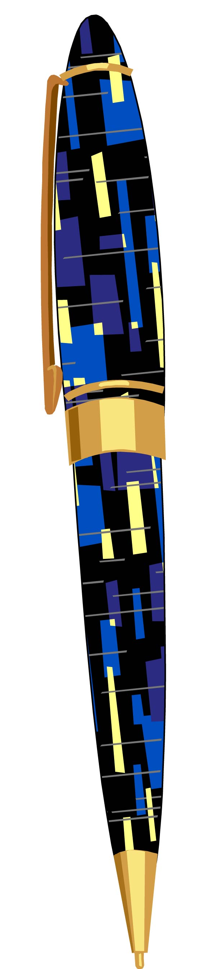 | 
Image one | Image two | Image three | Image four

6. Which one of the images above demonstrates the basic design principle of repetition?

(a) Image one
(b) Image two
(c) Image three
(d) Image four

7. Which one of the following file formats allows for transparency once exported?

(a) jpeg (jpg)
(b) gif (gif)
(c) bmp (pict)
(d) tiff (tif)

8. Using a form on a website is an example of

  - data security.
  - data entry.
  - validation.
  - disposal/archiving.




9. The above two images demonstrate a principle of design. This is the principle of

(a) symmetry.
(b) repetition.
(c) balance.
(d) emphasis.

10. Which one of the following statements is false?

(a) A bridge is a device that connects and passes packets between two network segments on the same network that use the same communication protocol.
(b) ISDN stands for Internet Services Digital Network.
(c) A router is a device that connects any number of LANs.
(d) A switch is a device used to provide connection to all devices on the network.

11. What is the most secure way to protect your digital data on the internet against
unauthorised access?

(a) strong encryption
(b) password protection
(c) biometric device
(d) computer lock

12. What part of a computer holds the data only temporarily?

(a) hard disk drive
(b) central processing unit
(c) primary storage
(d) secondary storage

13. What Federal Government Act provides an employer the opportunity to observe his employees’ ‘work related’ productivity?

(a) Freedom of Information Act
(b) Privacy Act
(c) Workplace Relations Act
(d) Public Works Act

14. A student wants to choose a storage format for a photo story she has produced which has a file size of 900 000 kilo bytes. Which would be the most suitable storage medium?

(a) Floppy Disk (1.44 MB)
(b) CD-RW (800 MB)
(c) DVD-R (4.7 GB)
(d) USB (Flash or Thumb) Drive (256 MB)

This space has been left blank intentionally
15. A publicity officer employs a photographer to take some promotional photographs at a product launch. As the photos need to be used in various screen and print publications, the following screen shots show characteristics of differing file formats. Which one of the following formats should the publicity officer choose to receive the photos for maximum versatility?

(a)
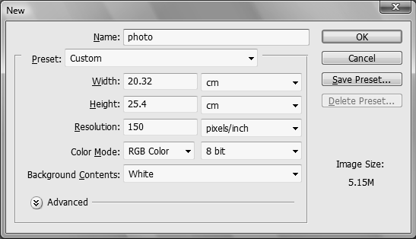

(b)
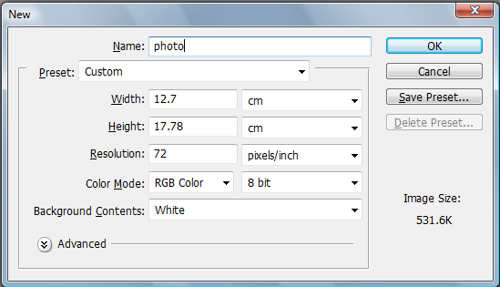

(c)
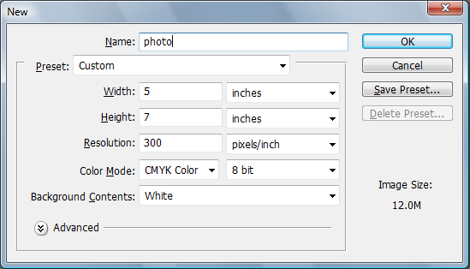

(d)
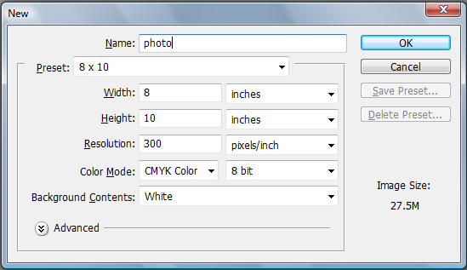
16. Complete the sentence with one of the words below.

A web site that uses to secure its data is known as a secure site.

- hypertext
- decryption
- encryption
- passwords

17. Employers aim to provide optimum work conditions to ensure greater work efficiency and ensure employee comfort. Consultants were asked to submit four recommendations to reduce eye fatigue. Which one of the following recommendations would be the most effective to reduce eye fatigue?

- Regular breaks and eye exercises, ergonomic workstation design, limit monitor glare and reflection, 19” LCD monitor.
- Regular breaks and eye exercises, ergonomic workstation design, limit monitor glare and reflection, 19” CRT monitor.
- Regular breaks and eye exercises, ergonomic workstation design, fluorescent lighting, 19” monitor.
- Two minutes break every 30 minutes, ergonomic workstation design, natural lighting, plasma screen.

18. The Australian Federal Government has recognised the need to protect consumer interest by passing legislation to enable CD owners to copy recorded music they own so that it can be played on their own MP3 devices.

What is the correct term used in the Australian Copyright Act of 1968 to describe this practise?

- Common Use
- APRA Licence
- Fair Dealing
- Public Domain

19. Which system would you recommend to a website developer who produces their own graphics?

  - Dialup 56Kb, 512 MB RAM, 2.6 GHz processor, 20 GB Hard drive.
  - ADSL 512Kb/s, 2 GB RAM, Intel Duo Core 2.16 GHz, 80 GB Hard drive.
  - ADSL 512 Kb/s, 256 MB RAM, Dual AMD 2.01 GHz, 100 GB Hard drive.
  - Dialup 56Kb, 2GB RAM, AMD 2.01 GHz, 10 GB Hard drive.

20. Which one of the following is not a type of backup?

- differential
- incremental
- internal
- full

END OF SECTION ONE
SECTION TWO: SHORT ANSWER (30 MARKS)

Candidates are required to choose one of the following options, according to their final units of study. There are six compulsory questions in each option.

Option A: For candidates who have studied 2A/2B units
Option B: For candidates who have studied 2B/3A units
Option C: For candidates who have studied 3A/3B units

Tick one of the boxes below to indicate your choice of option.

Option |  | Pages
A: For 2A/2B candidates only |  | 10–14
B: For 2B/3A candidates only |  | 16–20
C: For 3A/3B candidates only |  | 22–25

Now turn to the relevant pages and answer the questions for the option you have selected.

OPTION A: CANDIDATES FOR 2A/2B (30 MARKS)

Only attempt the following questions if you studied units 2A and 2B in 2008.

There are six questions in this section. Attempt all questions.

Write your answers in the spaces provided.

Suggested working time for this section is 35 minutes.

Question 1 (5 Marks)

A company provides all new employees with a booklet relating to the appropriate use of ICT within the company.

- Explain why the company provides new employees with this type of booklet. (2 marks)

- List three distinctly different rules and provide a reason why each rule should be included in a booklet relating to the use of ICT within a company.
(3 marks)
Rule 1:
Reason:

Rule 2:
Reason:

Rule 3:
Reason:

Question 2 (5 Marks)

You have been employed to evaluate ACME Solutions’ expanding ICT requirements. Sales Consultants require access to the internet and ACME’s documents with customers whilst off-site. Your solution is to incorporate digitally converging technologies for use by the sales consultants.

(a) Explain what digital convergence means and give an example. (2 marks)

(b) Using a PDA or smart phone (or other reasonable use of technology) explain how digital
convergence could assist ACME Solutions. (3 marks)

Question 3 (5 Marks)

You have been asked by a friend to provide some advice regarding security and different types of software licensing for their new computer. The computer has internet access and will be used for both home and business purposes.

(a) Explain, using examples, key differences between freeware, shareware and proprietary software licenses. (3 marks)

(b) Your friend is also concerned about how she can protect her computer and personal information against malicious software. What is malicious software and what measure can she take to protect herself against it?
(2 marks)

Question 4 (5 Marks)

A travel firm Land Ahoy! has awarded you and your team with a contract to create an interactive product as well as ideas for marketing merchandise. However, prior to commencing this work, it is essential that the people working with you have a clear understanding of the terminology that they will be using.

(a) Select four (4) file extension types from the following list:

          - .jpeg (jpg)
          - .gif (gif)
          - .bmp (pict)
          - .tiff (tif)
          - .avi
          - .wav

(i) Define the four (4) file extensions. (2 marks)

(ii) Why would you use these types of files? (2 marks)

(b) File types such as jpeg (jpg) use lossy compression. Explain this concept.
(1 mark)

Question 5 (5 Marks)

(a) What is Occupational Overuse Syndrome? (2 marks)

(b) List three examples of how Occupational Overuse Syndrome can be reduced in the workplace. (3 marks)

Question 6 (5 Marks)

(a) What is meant by ‘inclusivity’ in ICT and why is it important? (2 marks)

(b) Identify three disadvantaged groups and for each group provide one example of an ICT solution that enables easier access. (3 marks)

END OF OPTION A
TURN TO PAGE 27 FOR SECTION THREE

OPTION B: 2B/3A CANDIDATES (30 MARKS)

Only attempt the following questions if you studied units 2B and 3A in 2008.

There are six questions in this section. Attempt all questions.

Write your answers in the spaces provided.

Suggested working time for this section is 35 minutes.

Question 1 (5 Marks)

A company provides all new employees with a booklet relating to the appropriate use of ICT within the company.

- Explain why the company provides new employees with this type of booklet. (2 marks)

- List three distinctly different rules and provide a reason why each rule should be included in a booklet relating to the use of ICT within a company.
(3 marks)
Rule 1:
Reason:

Rule 2:
Reason:

Rule 3:
Reason:

Question 2 (5 Marks)

You have been employed to evaluate ACME Solutions’ expanding ICT requirements. Sales Consultants require access to the internet and ACME’s documents with customers whilst off-site. Your solution is to incorporate digitally converging technologies for use by the sales consultants.

(a) Explain what digital convergence means and give an example. (2 marks)

(b) Using a PDA or smart phone (or other reasonable use of technology) explain how digital
convergence could assist ACME Solutions. (3 marks)

Question 3 (5 Marks)

You have been asked by a friend to provide some advice regarding security and different types of software licensing for their new computer. The computer has internet access and will be used for both home and business purposes.

(a) Explain, using examples, key differences between freeware, shareware and proprietary software licenses. (3 marks)

(b) Your friend is also concerned about how she can protect her computer and personal information against malicious software. What is malicious software and what measure can she take to protect herself against it?
(2 marks)

Question 4 (5 Marks)

You have been asked to research game consoles and decide to use Blog websites, moderated user forums and online Encyclopaedias.

(a) Explain what each research source is, in terms of the quality of information it provides.
(3 marks)

(b) What dangers exist in using some of these research sources by people looking to make an informed decision? (2 marks)

Question 5 (5 Marks)

A school is considering listing an MP3 player or similar pocket sized device on the students’ stationery list.

(a) Identify four (4) issues and justify why the school should or should not encourage parents to purchase these devices. (4 marks)

(b) You endeavour to transfer files to your computer from your MP3 player but cannot do so. Apart from corruption, what could be the cause of the problem? (1 mark)

This space has been left blank intentionally

Question 6 (5 Marks)

Gerry Angalopousinium was trying to complete an online job application form from a prospective employer website. He correctly fills in the required information which is; Name, Surname, Address, Suburb and Contact phone number. However, when Gerry presses the ‘submit’ button to advance to the next stage of the online application, he receives an ‘error’ message, and this prevents him from submitting his application.

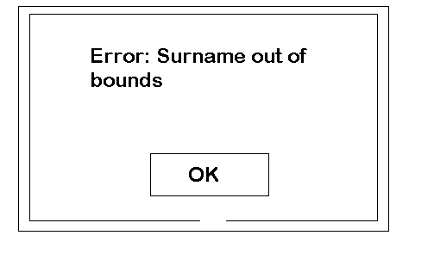
- What is the possible cause for this error? (1 mark)

- Outline two (2) ways for troubleshooting this situation that would provide the user with a better outcome. (2 marks)

- Should this type of error be considered as an indicator for re-looking at the system design? Provide one (1) reason to explain why or why not this would be necessary.
(2 marks)

END OF OPTION B
TURN TO PAGE 27 FOR SECTION THREE
OPTION C: 3A/3B CANDIDATES (30 MARKS)

Only attempt the following questions if you studied 3A and 3B in 2008.

There are six questions in this section. Attempt all questions.

Write your answers in the spaces provided.

Suggested working time for this section is 35 minutes.

Question 1 (5 Marks)

A company provides all new employees with a booklet relating to the appropriate use of ICT within the company.

- Explain why the company provides new employees with this type of booklet. (2 marks)

- List three distinctly different rules and provide a reason why each rule should be included in a booklet relating to the use of ICT within a company.
(3 marks)
Rule 1:
Reason:

Rule 2:
Reason:

Rule 3:
Reason:

Question 2 (5 Marks)

You have been employed to evaluate ACME Solutions’ expanding ICT requirements. Sales Consultants require access to the internet and ACME’s documents with customers whilst off-site. Your solution is to incorporate digitally converging technologies for use by the sales consultants.

(a) Explain what digital convergence means and give an example. (2 marks)

(b) Using a PDA or smart phone (or other reasonable use of technology) explain how digital
convergence could assist ACME Solutions. (3 marks)

Question 3 (5 Marks)

You have been asked by a friend to provide some advice regarding security and different types of software licensing for their new computer. The computer has internet access and will be used for both home and business purposes.

(a) Explain, using examples, key differences between freeware, shareware and proprietary software licenses. (3 marks)

(b) Your friend is also concerned about how she can protect her computer and personal information against malicious software. What is malicious software and what measure can she take to protect herself against it?
(2 marks)

Question 4 (6 Marks)

State in terms of cost or functionality three possible advantages and three disadvantages of multiple stand alone workstations compared with multiple networked computer workstations for a local business.
Advantages:

(3 marks)
Disadvantages:

(3 marks)

Question 5 (4 Marks)

A job advertisement for an ICT position requires applicants to detail their ICT skills. In terms of current industry trends, discuss the ICT skills that the employer could be seeking in applicants.

Question 6 (5 Marks)

In working to design a new corporate identity for a business, talking to your client and asking the right questions are essential to producing a quality product that meets the needs of the client. What questions would you ask your client when developing your design brief and why?

END OF OPTION C
TURN TO PAGE 27 FOR SECTION THREE

THIS PAGE HAS BEEN LEFT BLANK INTENTIONALLY

SECTION THREE: EXTENDED ANSWER (50 MARKS)

Candidates are required to choose one of the following options, according to their final units of study. There are two compulsory questions in each option.

Option A: For candidates who have studied 2A/2B units
Option B: For candidates who have studied 2B/3A units
Option C: For candidates who have studied 3A/3B units

Tick one of the boxes below to indicate your choice of option.

Option |  | Pages
A: For 2A/2B candidates only |  | 28–34
B: For 2B/3A candidates only |  | 36–40
C: For 3A/3B candidates only |  | 42–49

Now turn to the relevant pages and answer the questions for the option you have selected.

OPTION A: 2A/2B CANDIDATES (50 MARKS)

Only attempt the following questions if you studied 2A and 2B in 2008.

There are two questions in this section. Attempt both questions.

Write your answers in the spaces provided.

Suggested working time for this section is 50 minutes.

Question 1 (25 Marks)

Mr Johnson’s Applied Information Technology class has been instructed to create a website about their favourite place. The class have completed an activity about Australian copyright law and Mr Johnson warns the students that marks will be deducted from their final score if the students infringe copyright in the task. Not wanting to jeopardise his grade, Barry Barnes persuades his parents to drive him to his favourite place and takes a number of photographs to use on his website.

When the students present their finished site to the class, Barry notices that Molly Morton has used a number of pictures on her website that he knows must have been taken by a professional photographer and she has not cited the source of the images. Barry complains to Mr Johnson that he thinks Molly has used copyrighted images on her website. Molly defends herself, claiming that she got the images off a government website and was allowed to use the images without restriction because they were in the public domain.

(a) Explain what ‘public domain’ means. (1 mark)

(b) Is Molly’s belief that images on a government website are in the ‘public domain’ correct? Explain why Molly may or may not be correct. (6 marks)

(c) How does the Copyright Act of 1968 register and manage copyrighted materials in the ‘public domain’? (4 marks)

(d) If Barry is correct, and Molly’s use of the photographs infringes the Copyright Act of 1968, discuss five (5) possible ways in which Molly could make her website comply with copyright legislation. (5 marks)

(e) (i) Explain what a cascading style sheet is and give an example. (2 marks)

(ii) Why would web-designers advise Molly to use cascading style sheets in her
website? (1 mark)

(f) Websites which have a lot of visual content can cause problems for some viewers. Why is it important that Molly’s website be accessible for all users? (2 marks)

(g) Give four (4) measures that Molly could incorporate into her website design to allow
ease of access for all users? (4 marks)

Question 2 (25 Marks)

The Riverview Restaurant has recently changed from using a handwritten meal ordering system. The restaurant has installed a computer-based meal ordering system for wait-staff to enter customer orders into a small hand held device.

- Identify three advantages and three disadvantages of implementing this type of system.
Advantages:

(3 marks)
Disadvantages:

(3 marks)

(b) The management of the restaurant has noticed that people are embracing technological change more readily, in their personal, social, economic and community lifestyles. Discuss these trends. (8 marks)

(c) As restaurant staff is now using the hand held devices, what type of network would most likely be used? (1 mark)

(d) Using the hand held device, list a possible

    - data input; (1 mark)

    - output which could be both printed and electronic. Detail the information that could be stored. Give two (2) examples. (2 marks)

- List and describe other examples of portable computer technology that could assist different types of businesses to deliver their services or products. (3 marks)

(f) Environmental issues are a major focus nowadays. What impact, both positive and negative, could the restaurant’s hand held device have on the environment?
(4 marks)

END OF OPTION A
TURN TO PAGE 50 FOR SECTION FOUR

OPTION B: 2B/3A CANDIDATES (50 MARKS)

Only attempt the following questions if you studied 2B and 3A in 2008.

There are two questions in this section. Attempt both questions.

Write your answers in the spaces provided.

Suggested working time for this section is 35 minutes.

Question 1 (25 Marks)

Refer to your learning context to provide specific examples for this question. (For example: tourism, workplace, entertainment, education and training, etc.)

ICT as a marketing/advertising tool is becoming a dominant means by which businesses inform potential customers of their products and services, especially through the Internet.

- If companies wanted to advertise their products and services locally and nationally, what ICT services and infrastructures in Australia could they use? (5 marks)

- Discuss the impact that five (5) local and/or national ICT structures have on businesses’ abilities to get their products/services advertised to specific communities in Australia.
(15 marks)

(c) Why is Internet marketing/advertising becoming an essential medium for businesses to use? (5 marks)

Question 2 (25 Marks)

A group of students have created a multimedia presentation using footage they have captured and edited themselves. It has been saved in a very high quality format on the hard drive of one of the school’s computers. Their teacher wants the multimedia presentation to be available in a suitable format for them to view on their portable devices e.g. phones.

(a) What name is given to a technique to make a file or a data stream smaller for faster transmission or to take up less storage space? (1 mark)

(b) What specific form of this process would be used in the case described above, and what is its key processing feature? (2 marks)

(c) Outline the steps involved to convert the high quality multimedia presentation file to a format suitable for viewing on a portable device. Use correct terminology and technical details to support your statements. (12 marks)

(d) List the hardware and software you would use to complete the conversion outlined in
part 2(a) above, giving specifications and the way they will be used. (6 marks)

Hardware:

Software:

(e) Discuss what issues you would encounter in terms of viewing quality between the original and the final converted production. (4 marks)

END OF OPTION B
TURN TO PAGE 50 FOR SECTION FOUR

OPTION C: 3A/3B CANDIDATES (25 MARKS)

Only attempt the following questions if you studied 3A and 3B in 2008.

There are two questions in this section. Attempt both questions.

Write your answers in the spaces provided.

Suggested working time for this section is 35 minutes.

Question 1 (25 Marks)

Read the article below and answer the questions which follow.

Mobile apps slow business uptake
Jennifer Foreshew | September 25, 2007
MOBILE penetration in Australian businesses is an "escalating phenomenon", but mobile service providers are missing a major market opportunity, according to research.
The study, by analyst IDC, finds there is a large latent base of business users in need of mobilisation, and singles out first-time adopters of mobile communications and those who want to use mobile data channels more effectively with mobile email, internet protocol PBX directory functionality, and mission-critical business applications.
The report, Australia Business Mobile Vertical 2007-2011 Forecast and Analysis: Me Against The World, finds that businesses spent $4.25 billion on mobile voice, messaging and data services last year.
IDC Australia mobile and wireless research analyst Jerson Yau says it is crucial that mobility stakeholders inform the market of the benefits of mobility in a business context.
He says mobile systems and services that deliver a tangible return, improve cost efficiencies and offer a high level of manageability will have universal appeal among organisations irrespective of their particular industry or size of operations.
The report predicts there will be greater demand by the management hierarchy and workforce on the ground to mobilise business applications and processes to take advantage of the perpetually connected nature of mobile services.
It also forecasts that mobile non-voice services will experience double-digit growth over the five-year period and across all business verticals.
Professional services, manufacturing and primary industries, and the retail and wholesale sectors are leading spenders on business mobile services, the report says.
The large public sector, covering government, education and healthcare, is the mid-market with a blend of "leading and lagging" usage.
Australian IT.

Foreshew, J. (2007, September 25).
(a) The article refers to ‘mobile systems and services’. What are ‘mobile systems and services’? How would the acquisition of mobile technology impact on the physical ICT hardware structure and work practises within an organisation? (12 marks)

(b) What are some of the advantages and disadvantages to employees associated with using the types of mobile technology that are mentioned in this article? (5 marks)

(c) What additional factors would influence an organisation to endorse or reject the use of mobile technology? (8 marks)

This space has been left blank intentionally

Question 2 (25 Marks)

Read the following excerpts and answer the question that follows.
Swap Songs with Strangers

Excerpt 1:

“Imagine that you have a mobile device that can store and play back music files, for example a mobile phone with an MP3 player. As you encounter various people, the devices you are carrying connect to each other wirelessly and media agents from the other nearby devices check the status of your media collection. Based on what you have been listening to in the past and which files you already own, new music might spontaneously and autonomously “jump” from another device to yours (and vice versa). Later, when you listen to your songs, your Push!Music player also plays some newly obtained tunes that you had not heard before.”

Excerpt 2:

The creators of Push!Music have “…recently received a lot of attention in media and blogs, which is great fun! However, there are a couple of misunderstandings of Push!Music and our aims with the project... Just to clarify a few things.”

1. Push!Music is a research prototype, not a product. We have tested it in a small-scale user study but have at this point no plans to commercialize the technology.

2. The purpose is NOT to spread music or other content illegally. There are a number of systems that allow you to pay for songs you have downloaded via filesharing and even give compensation to the person you got it from, for instance Shawn Fanning’s Snocap. There are also several ways you can subscribe to “all-you-can-eat” downloads, for instance the current incarnation of Fanning's previous venture Napster. When a payment model is in place, Push!Music will simply help people find more music, which can only be good for the artists.

3. When we do our current user tests, we are careful to stay strictly within the limits of Swedish law: we only use music that the users have paid for, and we limit copying to within a small circle of friends.

4. Many have brought up issues like viruses, spam and unwanted songs, advertising, the problem of correctly predicting what someone will like, etc. We are of course aware of these as potential problems with new ideas but that is no reason to not explore them! We are building and testing prototypes to find out more about both problems and unexpected opportunities.

[Push!Music project http://www.viktoria.se/fal/projects/music/index.html].

(a) In excerpt 2 part 4, the vendor makes reference to viruses and spam. Outline some simple countermeasures and techniques one could employ to ensure that this possibility of attack is reduced. (4 marks)

(b) You found a virus scanner for your particular operating system on your MP3 player and so far it has not detected any malicious software. Due to convergence and utilities, these MP3 files are also downloaded to your desktop/laptop computer at home. On your recent download, your spyware scanner detected MP3.Trojan.Keylogger.Backdoor in one of the MP3 files.

- What is a Trojan/Backdoor? (1 mark)

- Provide two (2) possible reasons why your MP3 virus scanner did not detect the Trojan/Backdoor. (2 marks)

(c) Other than legal issues associated with the use of this ICT product under Australian Law, what ethical and moral issues could impact users in Australia, Sweden and elsewhere in the world? (18 marks)

END OF SECTION THREE
TURN TO PAGE 50 FOR SECTION FOUR
SECTION FOUR: PRODUCTION (100 MARKS)

Answer all parts to this question. Write your answers in the space provided. You may wish to use the Production Booklet for Part B.

Suggested working time for this section is 75 minutes.

Question 1

In order to enhance one of the business organisations listed below, you are to design one of the following:

- a web site, or
- a brochure, or
- an animation, or
- a computer game, or
- stationery logos required for a business.

Select one of the following business organisations:
- leisure/recreation, or
- food/beverage, or
- accommodation/travel, or
- sport/health, or
- education, or
- retail.

The design can be informational, instructional/educational, promotional, or for entertainment/edutainment purposes.

In developing your design you should apply a technology process, and justify all choices.

Part A (10 marks)

(i) Identify the purpose of the product being designed
(ii) Identify and analyse the target audience and their requirements of the information solution you are designing

Part B (50 marks)

Sketch and annotate at least three (3) possible design solutions. You must clearly show the progressive changes, including the final design and explain the elements and principles of design to be used. Use appropriate technical language where necessary.
Part C (40 marks)

Write a critical analysis of the final design, considering the following:

(i) The effectiveness of the final design for the intended target audience. Consider the functionality of the final design, the aesthetics and any possible environmental issues.

(ii) Identify where the product will be used. Discuss working and published file formats and identify the limitations/capabilities of the proposed software. Justify your selection of software based on the requirements for your final design.

(iii) Compare your final product design to a known available product with a similar purpose.

ACKNOWLEDGEMENTS

SECTION THREE: EXTENDED ANSWER (OPTION C: 3A/3B CANDIDATES)

Question 1: Foreshew, J. (2007, September 25). Mobile apps slow business uptake.
Retrieved February, 2008, from Australian IT website:
http://www.australianit.news.com.au/story/0,24897,22473261-15306,00.html.
© News Limited.

SECTION THREE: EXTENDED ANSWER (OPTION A: 2A/2B CANDIDATES)

Question 1: Push!Music. (n.d.). Retrieved February, 2008, from Viktoria Institute website:
http://www.viktoria.se/fal/projects/music/project.html.
[Push!Music project http://www.viktoria.se/fal/projects/music/index.html].
Published by the Curriculum Council of Western Australia
27 Walters Drive
OSBORNE PARK WA 6017

